
Anjuman-I-Islam’s

M. H. SABOO SIDDIK COLLEGE OF ENGINEERING
8, Saboo Saddik Polytechnic Road, Byculla, Mumbai, Maharashtra 400008

DEPARTMENT OF INFORMATION TECHNOLOGY

Mini Project ITL601 Business Intelligence LAB

Title of the Project

Sales Data Analysis using Star & Snowflake Schema (Business Intelligence Approach)

Supervisor/Guide

PROF.FARDEEN SHAIKH

REV - 2019 ‘C’ Scheme

University of Mumbai

Academic Year (2024 -25)

GROUP MEMBERS

STUDENT NAME | ENROLLMENT NO.
YAMIN KHAN | 242464
ABDURRAHMAN QURESHI | 242466
HAADIYA SAYED | 242467
SHAIKH RUMAAN | 242469
SHAIKH SAMEER | 242471

TABLE OF CONTENT

Sr.No | Content | Page No
1 | Problem Definition | 1
2 | Dataset Details | 2
3 | Methodology / Approach | 3
4 | Results And Visualizations | 5
5 | Conclusion or Business Insights | 7

PROBLEM DEFINITION

In today’s competitive business environment, organizations generate large volumes of sales data. However, raw data alone is not sufficient for decision-making. Businesses require structured data models and analytical techniques to extract meaningful insights.
The objective of this project is to:
- Design Star and Snowflake schemas for organizing sales data
- Apply Business Intelligence techniques to analyze sales performance
- Generate insights that help in decision-making and business growth

DATASET DETAILS
The dataset used in this project is a Sales Dataset containing transactional records.

Attributes include:
- Order ID
- Order Date
- Customer Name
- Region
- Product Category
- Product Name
- Sales Amount
- Quantity
- Profit

Data Source:
- Sample Sales Dataset (Manual)

Data Characteristics:
- Structured data format (rows & columns)
- Contains both categorical and numerical data
- Suitable for data warehousing and BI analysis
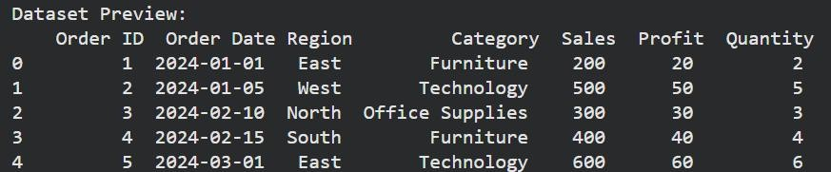

METHODOLOGY / APPROACH

Step 1: Data Preprocessing
- Removed missing values
- Converted date fields into proper format
- Cleaned inconsistent data

Step 2: Star Schema Design
A Star Schema consists of:
- Fact Table: Sales Fact (Sales, Profit, Quantity)

Dimension Tables:
  - Customer Dimension
  - Product Dimension
  - Time Dimension
  - Region Dimension

Structure:
- Central Fact Table connected to all dimensions
- Simple and fast for querying
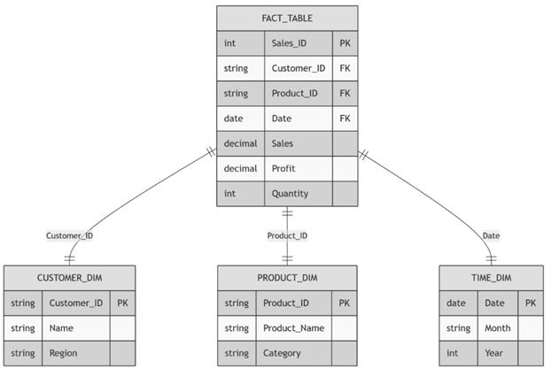

Star Schema Diagram

Step 3: Snowflake Schema Design
A Snowflake Schema is a normalized version of the Star Schema.

Example:
- Product Dimension → split into:
  - Product Table
  - Category Table
- Region → Country → City hierarchy

Advantages:
- Reduces data redundancy
- Improves data integrity
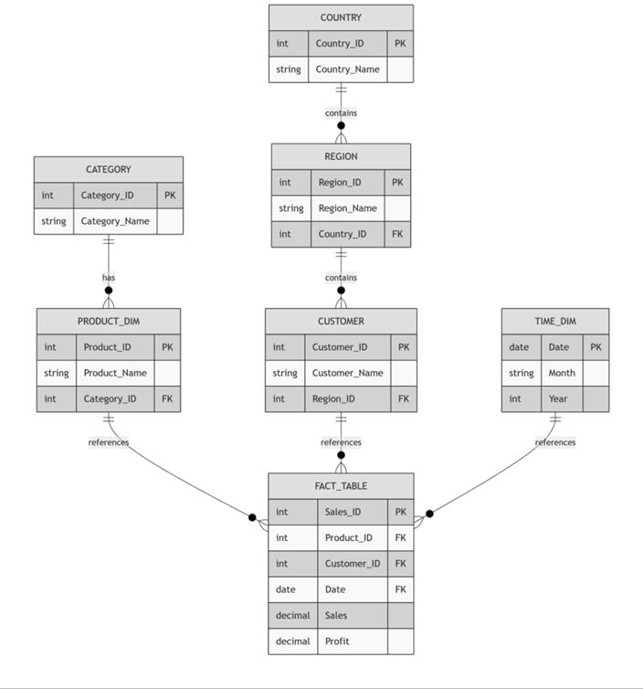
Snowflake Schema Diagram

RESULTS AND VISUALIZATION
Code :
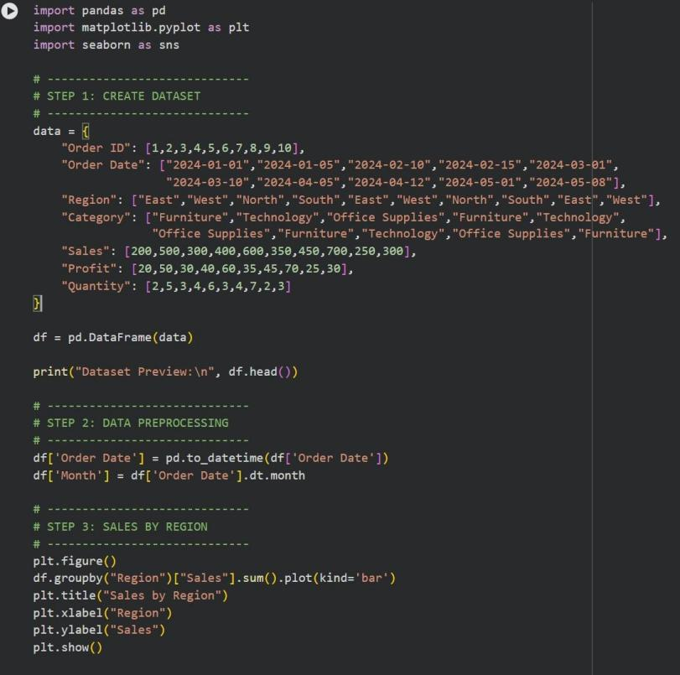
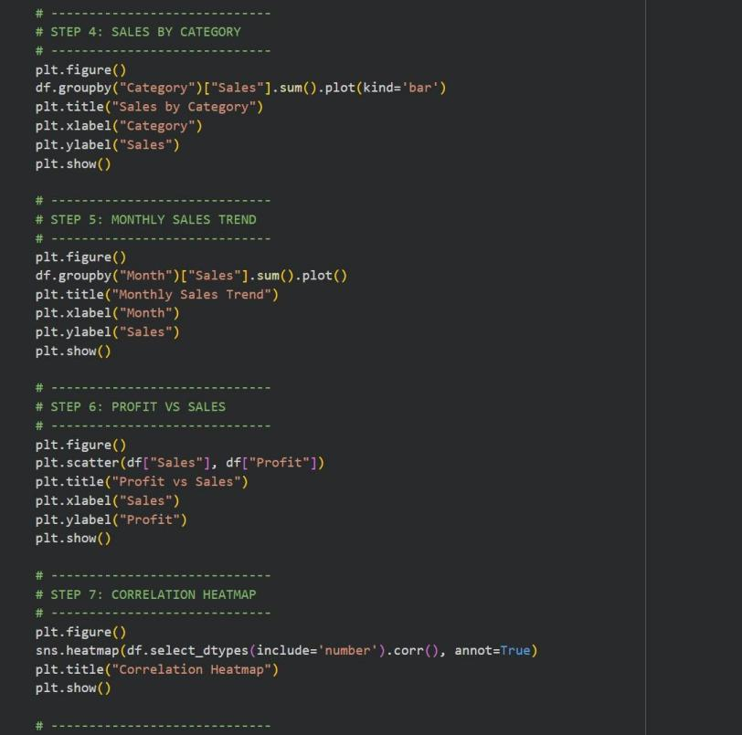
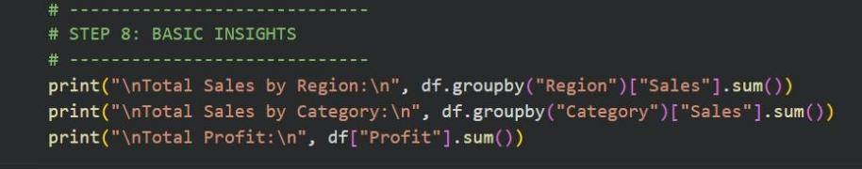

Output :
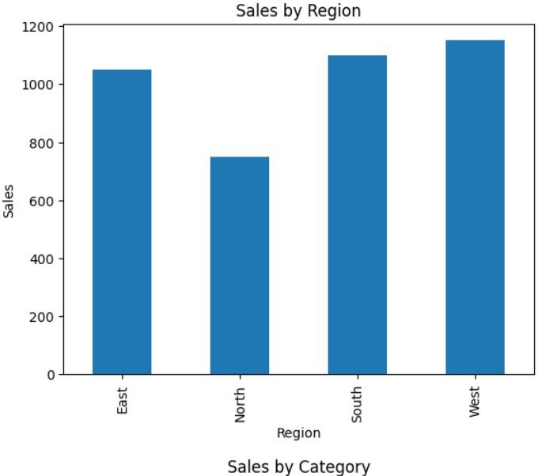
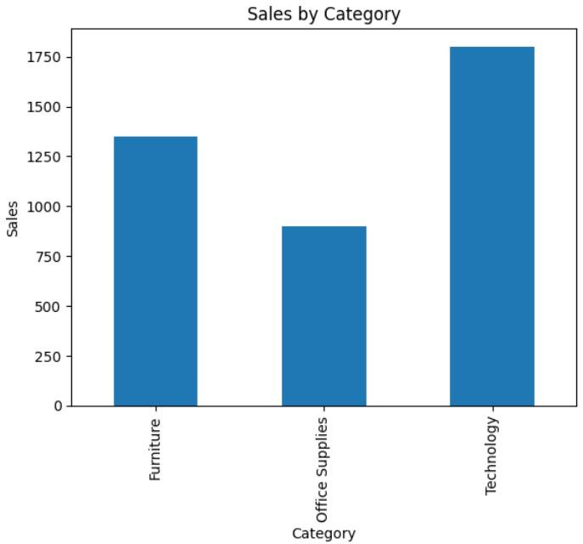

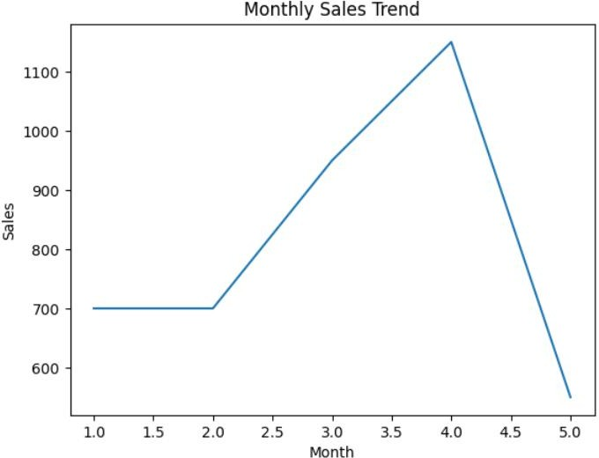
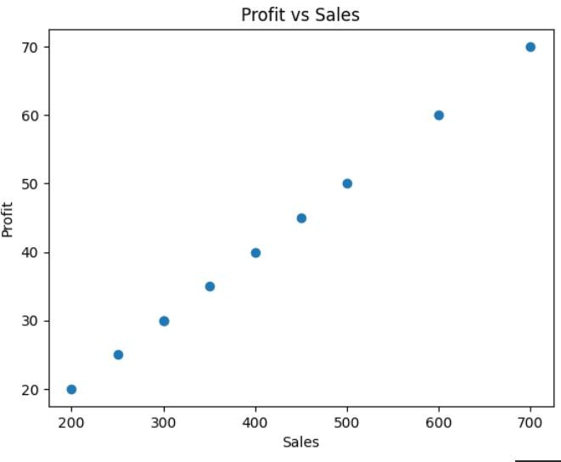
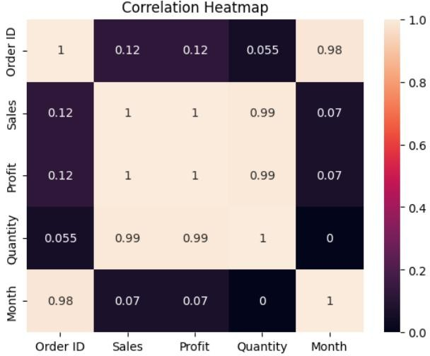
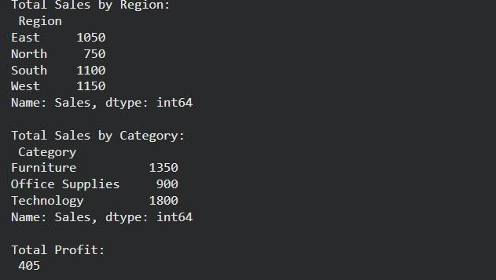

CONCLUSION OR BUSINESS INSIGHTS

Business Insights :
- Some regions contribute more revenue than others
- High sales do not always mean high profit
- Certain product categories dominate the market
- Seasonal trends affect sales performance

Conclusion : This project shows how Business Intelligence techniques and Star & Snowflake schemas help organize and analyze sales data efficiently. The use of visualizations made it easier to identify patterns, trends, and relationships, supporting faster and better decision-making.
The analysis revealed that some regions generate higher sales, while high sales do not always mean high profit. Seasonal trends were observed, helping in planning inventory and marketing. Correlation insights also showed how sales, profit, and quantity are related, enabling businesses to improve performance and profitability.

